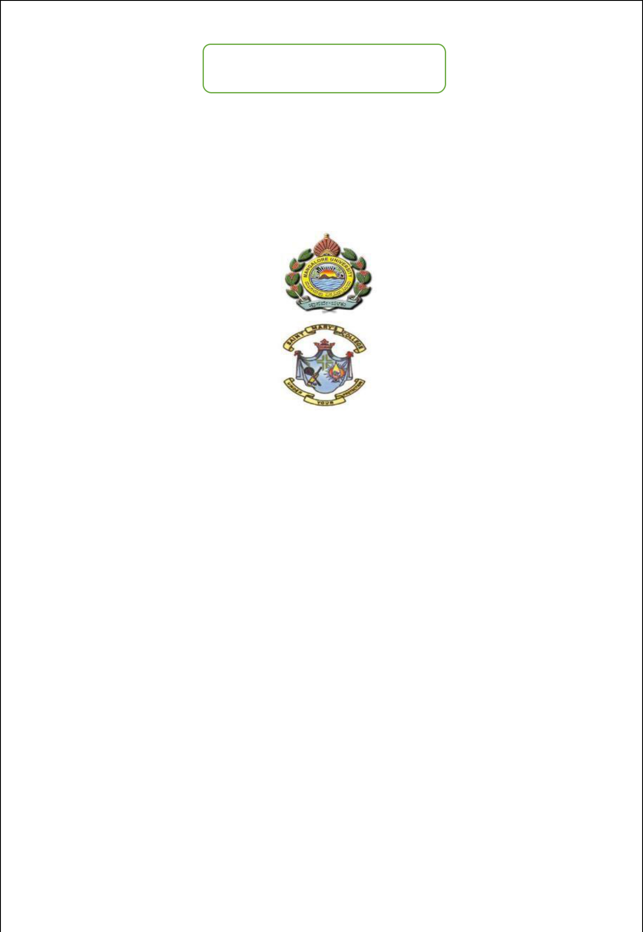
PROJECTON

“HUMAN CAPITAL MANAGEMENT”

BACHELOR OF COMPUTER APPLICATION

OF

MANGALORE UNIVERSITY

By

Shettigar Hemashree Sudarshan(U05CS21S0028) Deeksha Amin(U05CS21S0062) M Anagha(U05CS21S0063)

INTERNAL GUIDE

Prof. Prakash Acharya

Department of computer science

St. Mary’s college,shirva

DEPARTMENT OF COMPUTER SCIENCE

ST. MARY’S COLLEGE ,SHIRVA-57411

2023-2024

SYNOPSIS
CHP 1. INTRODUCTION

1.1 TITLE OF THE PROJECT: HUMAN CAPITAL MANAGEMENT

The Human Capital Management System is also referred as Human Resources Management System is a web-based information system which provides attendance related information of employee to admin. System allows both admin and employees to login by their username and password. It allows admin to add and manage the employee details and also allows employee to apply leave.

1.2 OBJECTIVE OF THE PROJECT:
The objectives of the HC Management System to develop a system which helps the admin to maintain employee’s details, salary details, department details, view attendance, leave, resignation request and the employee can view their attendance, salary details, can apply leave and resignation

1.3 PROJECT CATEGORY:
This project is web based application comes under Relational Datebase Management System (RDBMS).

1.4 Languages/Frameworks used:

Front End: PHP,HTML,CSS,JAVASCRIPT

Back End: MySQL

1.5 MODULES :

The program consists pf following modules:

HR Module:

- HR login

- View attendance

- Department

- Leave

- Salary

- View resignation

- Job vacancy
Employee Module:

- Employee login

- Registration

- Attendance

- Salary details

- Leave

1.6 Module Descriptions:

1.6.1 HR Admin:
Admins are able to approve, view or reject the details of employee.

Login:
This module allows the admin to login by using their username and password.

Employee:
Admin can manage the employee details.

View attendance:
This module allows admin to view the attendance details of the employee.

Department:
This module allows admin to manage the department details.

Add department:
This module allows admin to add new department to the particular employee.

Leave:
This module allows admin manage leave for the employee.

Leave Approval:
This module allows the admin to Approve or reject the leave of employee.

Leave History:
This module contains leave history of employees.

Salary:
This module allows admin to displays salary of the particular employee.
Add Salary Structure:
This module allows admin to add salary to the employee.

View Resignation:
This module allows admin to approve list of employee’s resignation and then employee will get a message.

Notice:

Add Notice:
This module allows admin to add the notice to the particular employee.

Manage Notice:
This module allows admin to view, delete or modify the notification.

Update password:
This module allows the admin to update their password.

1.6.2 Employee Module:
Employee is responsible for performing the task assigned by the admin and they can also view their salary details or leave details.

Registration:
Creating new employee profile by providing their details.

Login:
This module allows the employee to login by using their username and password.

Attendance:
Employee can view their attendance details.

Salary details:
Employee can view their salary details.

Leave:
This module allows employee to apply and view their leave.

Leave Apply:
Using this module, Employee can apply leave with valid reason.

View Previous Leave:
Using this module, Employee can view their previous leave.

Notifications:
It displays the notification providing some information.

Apply Resignation:
Using this module, Employee can apply their resignation.

1.7 Future Scope for the project:

This is a web application project future it can be implemented in android studio.Webiste will provide training to the freshers in Blog plage

1.8 Hardware requirements specification:

- Disk Storage: 80GB of free disk space or higher.

- RAM-1 GB

1.9 Software requirements specification:

- Windows 7 or higher, any other OS.

- XAMPP Server

- HTML, PHP, CSS, MYSQL.

- Notepad++ or similar editor for writing code.

LITERATURE SURVEY

CHP 2. LITERATURE SURVEY

HTML
HyperText Markup Language or HTML is the standard markup language for documents designed to be displayed in a web browser. It defines the content and structure of web content. Web browsers receive HTML documents from a web server or from local storage and render the documents into multimedia web pages. HTML describes the structure of a web page semantically and originally included cues for its appearance.

CSS
Cascading Style Sheets (CSS) is a style sheet language used for specifying the presentation and styling of a document written in a markup language such as HTML or XML. CSS is designed to enable the separation of content and presentation, including layout, colors, and fonts.

JAVASCRIPT
JavaScript (JS) is a dynamic computer language. It is most commonly used as part of whose implementations allow client-side scripts the user, control the browser, communicate and alter the document content that is displayed. used in server-side programming, game development and the creation of desktop and mobile applications. JavaScript's syntax was inspired by Java's and is relatively easy to learn compared to other popular languages like C++Open and cross-platform computer programming It is most commonly used as part of web browsers, side scripts to interact with the user, control the browser, communicate asynchronously, that is displayed. It is also being.

PHP
PHP stands for Hypertext Pre-processor. PHP is a server-side scripting language designed for web development but also used as a general-purpose programming language. As of January 2013, PHP was installed on more than 240 million websites and 2.1 million web servers. PHP code can be simply mixed with HTML code or it can be used in combination with various templating engines and web frameworks. PHP files can contain text, HTML tags and scripts files can have a file extension of .php, .php4, .phtml, .php3, .php5, .phps. PHP files can contain text, HTML tags and scripts.

MYSQL
MySQL is a database system used on a web. MySQL is a database system that runs on a server. MySQL is ideal for both small and large applications. MySQL is very fast, reliable, and easy to use. MySQL uses standard SQL.

XAMPP
XAMPP is a free and open-source cross-platform web server. XAMPP stands for Cross-Platform(X), Apache(A), Maria DB(M), PHP(P)and Perl(P). It is a simple, lightweight Apache distribution that makes it extremely easy for developers to create a local web server for testing and deployment purposes.

SOFTWARE
REQUIREMENT
SPECIFICATION

CHP 3. SOFTWARE REQUIREMENT SPECIFICATION

3.1 Introduction:
Software Requirement Specifications is a document which specifies the requirement for developing software. The purpose of the document state the overall structure of the project functionality and to guide the developer of the software about the requirement of the client. It specifies the basic requirement constraint and interface of the proposed system. The software document will be basic for final system.

3.2 Purpose:
This document aims to give a brief description about the HR Management System Project. With the help of this document the needs of the company and the solution that will be provided to that needs will be clearly presented. In other words this document will provide a basis for validation and verification.

3.3 Scope:
The main objective of developing helps the employee by providing all kind of job relayed information in the website. HRMS is a website application managed by the Admin of the company of that website, which helps the employee.
3.4 Overall Description:
3.4.1 Product perspective:
3.4.1.1 System interfaces:
This application runs on the chrome or firebox on windows.
3.4.1.2 User interfaces:
This application provides menus, buttons, grids allowing for easy Control by a keyboard and a mouse.
3.4.1.3 Hardware interfaces:
For hardware interfaces primary input and output devices are
Used.
3.4.1.4 Software interfaces:
This application allows to PHP, JAVASCRIPT and MYSQL server.
3.4.1.5 Communication interfaces:
This application uses internet as communication interfaces.
3.4.1.6 Interfaces with server:
This application allows to interface with MySQL server, XAMPP.
3.4.2 Product functions:
The project will work based on the modules.
• HR Admin:
HR admin allows you to add, remove, update employee details, view attendance, approval of leave, manage salary details, and can also view resignation details.
• Employee:
Employee allows you to view the salary details, can apply leave, view attendance details and can also update their profile.
3.4.3 User characteristics:
HC Management System is an application that assist the HR in capturing and storing employee’s records. Both Admin and Employee should have the basic knowledge of English and computer to work with this application.
3.4.4 General constraints:
General constraints describe how the product operates inside the various Circumstances.
• This application runs on window7 or above, OS screen resolution with 1680 X 1050.
3.4.5 Assumptions and Dependencies:
These factors are not design constraints on the software but any changes to these factors can affect the requirement in the SRS.

Ex: Some operating system required specific hardware configuration and our application (software) run in window7 or above operating system.

3.5 Functional requirements:
3.5.1 HR Admin:
3.5.1.1 Login:
a) Input: Username and Password
b) Process: Checks whether the given username and password is proper or not. If the given information is not correct then it will display’s the error message else it will take user to the next page.
c) Output: Displays Login successful message.
3.5.1.2 Employee:
3.5.1.2.1 Manage Employee:
a) Input: Employee-id
b) Process: In this, admin will view and accept the registration request of the employee.
c) Output: Display the successful message
3.5.1.3 View attendance:
a) Input: username
b) Process: In this, Employee attendance will be load from the attendance table.
c) Output: The employee attendance will be displayed.
3.5.1.4 Department:
3.5.1.4.1 Add department:
a) Input: Employee-id and Department name
b) Process: In this, new department will be added to the database.
c) Output: Display the successful message.
3.5.1.4.2 Manage department:
a) Input: username
b) Process: In this, Department will be deleted.
c) Output: Display the successful message.
3.5.1.5 Leave:
3.5.1.5.1 Leave approval:
a) Input: Employee-id
b) Process: If the reason is valid then admin will approve the leave or if the reason is invalid then admin will reject the leave.
c) Output: The approved or rejected message will be displayed to the employee.
3.5.1.5.2 Leave history:
a) Input: Employee-id
b) Process: Load the leave history of employee f from the database.
c) Output: Display the leave history of employee to the admin.
3.5.1.6 Salary:
3.5.1.6.1 Add salary:
a) Input: Username, department and basic salary.
b) Process: The addition of all these information will be added to the database.
c) Output: Display the successful message.
3.5.1.6.2 Manage salary:
a) Input: Username, department and basic salary.
b) Process: The edited or deleted information will be stored in the database.
c) Output: Display the successful message.
3.5.1.7 View resignation:
a) Input: Employee-id
b) Process: Retrieve the resignation from the database.
c) Output: Display employee resignation requests.
3.5.1.8 Notice:
3.5.1.8.1 Add notice:
a) Input: Employee-id and notice content
b) Process: Add new notice to the employee.
c) Output: Display successful message.
3.5.1.8.2 Manage notice:
a) Input: notice-id and new content
b) Process: The edited or deleted information will be stored in the database.
c) Output: Display successful message.
3.5.1.9 Report:
a) Input: data
b) Process: retrieve the data from the database
c) Output: Display the graph line structure and pir chart to the admin.

3.5.1.10 Update password:
a) Input: Username and new password
b) Process: The updated password will be stored in the database.
c) Output: Display successful message.

3.5.1.11 Logout

3.5.2 Employee:
3.5.2.1 Registration:
a) Input: Employee-id, Username, Phone number, Address, Gender, Date of birth, Date of joining, Department, Qualification, Email-id, Password.
b) Process: If the information is valid then, it is stored in the database.
c) Output: Display the successful message.
3.4.2.2 Login:
a) Input: Username and Password
b) Process: It checks whether the given username and password is valid or not. if it is valid then displays the next page to the user and if it is not valid then displays the error message.
c) Output: After validation the employee’s home page will be displayed.
3.5.2.3 Attendance:
a) Input: Date
b) Process: In this employee attendance will be retrieve from the attendance table.
c) Output: The employee attendance will be displayed.
3.5.2.4 Salary details:
a) Input: Salary details
b) Process: Retrieve the salary details of employee.
c) Output: Display salary details of employee.
3.5.2.5 Leave:
3.5.2.5.1 Apply leave:
a) Input: Employee details
b) Process: it checks whether the given details are valid or not. If it is valid then it is sent to the admin, if it is not valid then error message will be displayed.
c) Output: Display’s successful message
3.5.2.5.2 View previous leave:
a) Input: click view button
b) Process: Retrieve the leave from database.
c) Output: Display previous leave to the employee.
3.5.2.6 Notification:
a) Input: Click on bell icon
b) Process: Retrieve the notice from the database.
c) Output: Display’s the notification to the user.
3.5.2.7 Apply resignation:
a) Input: Employee details
b) Process: it checks whether the given details are valid or not. If it is valid then it is sent to the admin, if it is not valid then error message will be displayed.
c) Output: Display’s successful massage to the employee.
3.5.2.8 Profile:
3.5.2.8.1 Update password:
a) Input: Username and new password
b) Process: The new password will be stored in the database.
c) Output: Display’s successful message.
3.5.2.8.2 Setting:
a) Input: Click on setting button
b) Process: Employee details are retrieved from the database. Then employee can update his profile.
c) Output: Display successful message.

3.5.2.9 Logout

3.6 Design constraints:
3.6.1 Hardware constraints:
• Disk storage: 4GB of free disk space or higher.
• RAM-1GB
3.6.2 Software constraints:
Google chrome browser.
3.6.3 Fault tolerance:
Fault tolerance requirements can place a major constraint on how the system is to be designed. Fault tolerance requirements often make the system more complex and expensive so they should be minimised. Our application uses different validation and exception handling mechanism wherever it requires.
3.6.4 Security:
Each user can login to the application using their own username and password and only admin can view the database.
3.6.5 Standard compliances:
It specifies the requirements for the standard. For this we have follower standard format, type of navigations, naming conventions for buttons, labels and text buttons.

3.7 System attributes:
• Availability: Availability refers to the percentage of time that the infrastructure, system, or solution remains operation under normal circumstances in order to serve intended purpose.
• Portability: Portability, in relation to software is a measure of how easily an application can be transferred from one computer environment to another. A computer software application is considered portable to a new environment if the effort required to adapt it to the new environment is within reasonable limits.
• Reliability: Reliability refers to the probability that the system will meet certain performance standards in yielding correct output for a desired time duration. 17
• Maintainability: Maintainability refers to the phase with which you can repair, improve and understand software code. Software maintenance is a phase in the software cycle that starts after the customers has received the product.
• Scalability: Software scalability is an attribute of a tool or a system to increase its capacity and functionalities based on its user’s demand. Scalable software can remain stable while adapting to changes, upgrades, overhauls and resource reduction

SYSTEM DESIGN

CHP 4. System Design

4.1 Introduction:
Design is processes through which requirements are translated into a representation of the software. The purpose of the designing phase is to plan a solution for the problem specified by the requirements document i.e. the requirements are translated into software.

The design activity often results in three separate outputs:
- Architecture Design
- High Level Design
- Detailed Design

In architecture design the focus is on identifying components or subsystems and how they interact to each other. The high level design identifies the modules that should build for developing the system. In case of detailed design the focus is on how the modules are implemented in software.

System design is a solution, a "How to" approach to the creation of a new system. The important phase is composed of several steps. It provides the understanding of procedural details necessary for implementing the system recommended in the feasibility study. Emphasis is on translating the performance requirements into design specifications.

4.2 Methodology / Objective

The main objectives of the designs are:

1. Practicality

2. Efficiency

3. Flexibility

4. Completeness

5. Security

6. Verifiability

7. Traceability

4.3 Context Flow Diagram

Context flow diagram is a top level data flow diagram. It only contains one process node that generalises the function of the entire system in relationship to external entities. In context diagram the entire system is treated as a single process and all its inputs, outputs, sinks and sources are identified and shown

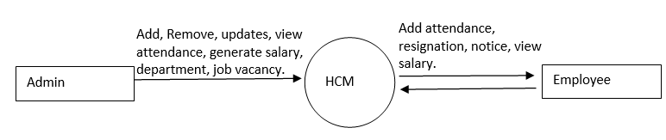

4.4 Data Flow Diagram

A data flow diagram is a graphical representation of the flow of data through an information system. A data flow diagram can also be used for the visualization of the data processing. It is common practice for a designer to draw a context level DFD. It shows the interaction between the system and the outside entities. This context level DFD, is then exploded to show more detail of the system being modelled.

A DFD represents flow of data through a system. Data flow diagrams are commonly used during problem analysis. It views a system as a function that performs the input into the desired output. A DFD shows movement of data through the different transformations or processes in the system.

Data Flow diagrams can be used to provide the end users with the physical idea of where the data they input ultimately has an effect upon the structure of whole system from order to dispatch to restock how any system is developed can be determined through data flow diagram. The appropriate register saved in database and maintained by appropriate authorities.

Notations in DFD

Symbol | Description
 | The circle or bubble represent a process. A process is named, and each process is represented by a named circle.
 | The source or sink is represented as a rectangular box. The source or sink is the net originator or the consumer of the data that flows in the system.
 | The arrow represented the flow of data through the system. The labelled arrows enter or leave the bubbles.
 | The database with the open box symbol.

Level 2:
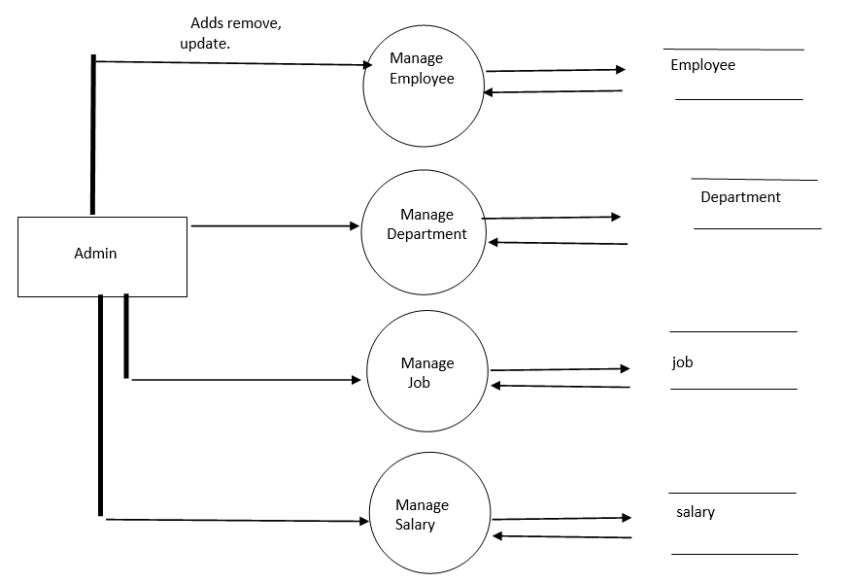
Level 2.1:
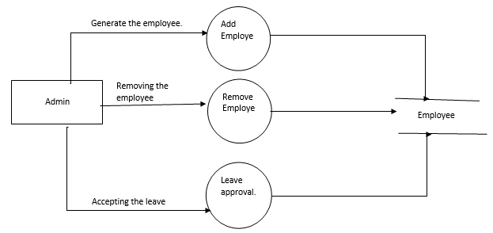

Level 2.2:

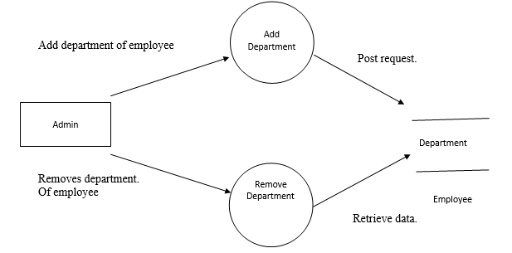

Level 2.3:
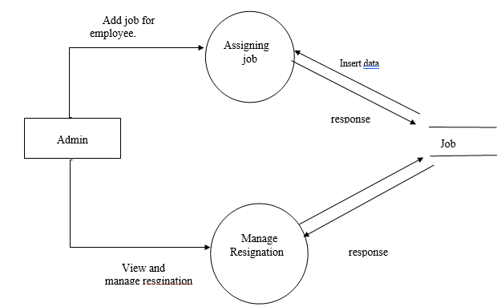
Level 2.4:

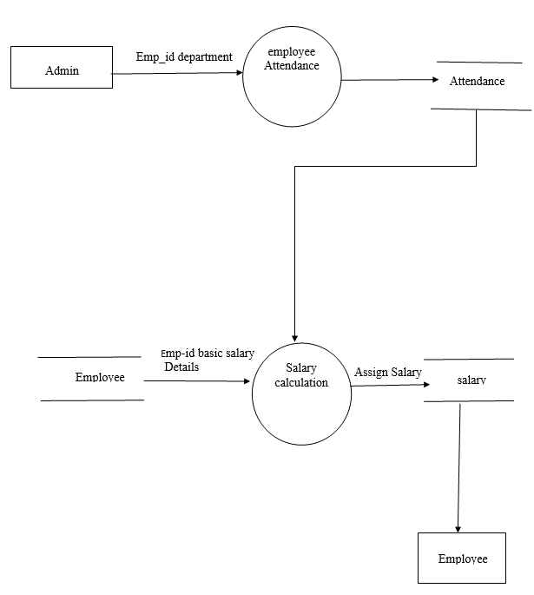
Level 3
View
Attendance
Retrieve attendance data.

Attendance

Employee

Apply Leave

Leave
Post Request

4.5 Entity Relationship Model (ER-Diagram):

A model that represents system date by entity and relationship sets

Entity: These are distinct things in the enterprice

Relationships: Meaningful interaction between the objects and entities.

Attributes: These are the properties of the entity and relationships.

Entity Relationship Diagram:

An ER model is an abstract way to describe a database. Describing a database usually starts with a relational database, which stores data in tables. Some of the data in these tables point to data in other tables for instance, your entry in the database could point to several entries for each of the phone numbers that are yours. The ER model would say that you are an entity, and each phone number is an entity, and the relationship between you and the phone numbers is 'has a phone number. Diagrams created to design these entities and relationships are called entity-relationship diagrams or ER diagrams.
In the below diagram we are considering the complex structures. It has large number of entities and relationships sets. Each entity set in ER Diagram linked more than one relationship sets.

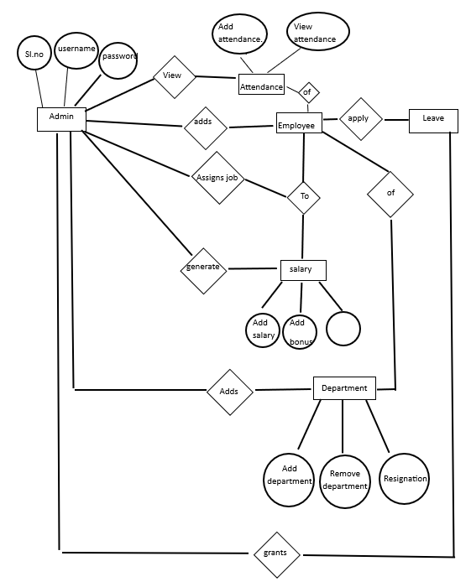

DATABASE DESIGN
5. Database Design

5.1 Introduction:
Database is a collection of related data. Relational database stores data in a table or relations. The data stored in a relation are arranged in records. Each record consists of set of attributes. Field can be referred to characteristics of records. This document describes the table that is used to design software, it's attributes, data types, constraints and relationship among those tables.

Database :
A Database is collection of related data, which can be of any size and complexity. By using the concept of Database, we can easily store and retrieve the data. The major purpose of a database is to provide the information, which utilizes it with the information’s that the system needs according to its own requirements.

Database Design :
Database design is done before building it to meet needs of end-users within a given information-system that the database is intended to support. The database design defines the needed data and data structure that such a database comprises.
The database is physically implemented using MYSQL.

The database for Human Capital is organized some tables:
Admin login table
HR login table

Each entity can be described as follows along with its attributes:

Admin login table

Field Name | Data Type | Constraints | Description
sl.no | Int (2) | Primary key | Serial number
username | Varchar (10) | Not null | Username
email | Varchar (20) | Not null | Email
password | Varchar (10) | Not null | password

HR login table

Field Name | Data Type | Constraints | Description
id | Int (11) | Primary key | Employee id
name | Varchar (255) | Not null | Name
dob | Date | Not null | Date of birth
phone | Varchar (20) | Not null | Phone
gender | Enum (‘male’,’female’,’other’) | Not null | Gender
password | Varchar (255) | Not null | Password
email | Varchar (255) | Not null | Email

DETAILED DESIGN

CHP 6. Detailed Design

6.1 Introduction:

The detailed design will decide the internal logic for the module, which implement the given specification. Detailed design is one of the design processes for software items. Detailed design, which is also known as logic design, involves the internal sign of the module and how the specification of the module can be satisfied. Detailed design is an extensor of system design.

The first step before the detailed design or code for a module can be developed is that the specification of the module be given precisely. Once the module is precisely specified, the external logic for the module that will implement the given identification can be decided.

The basic logic in detailed design is to specify the logic for the different modules that been specified during system design. Specifying the logic will require developing an algorithm that will implement the given specifications.

This phase includes the specification of table structures, which makes us understand the internal logic of the system. The tables are described with their field names, data type, table constraints, description of each field etc.

6.2 Structured English:

Login Form:

Begin
If (click on Login) then

Checks username & password, if the user exists then redirect into loading form

Else if (user does not exists) then

Display message “Invalid Username” or “Invalid Password”

End if
End

Department Form:

Begin
If (click on edit) then

Form is displayed with appropriate department details for the administrator to update

Else if (click on delete) then

The appropriate department record is deleted from the database

End if
End

Leave Form:

Begin
If (click on approve) then

The form is approved by the administrator

Else if (click on rejected) then

The form is rejected by the administrator

End if
End

CODING

CHP 7. CODING

7.1 Introduction:
The main goal of the coding or programming phase is to translate the design of the system produced during the design phase into code in a given programming language. It is then then executed on a computer to verify whether the design is correct or not. In coding phase the output document is code can be extremely useful in enhancing the understandability. Internal documentation of code is done using comments in the program. Comments are textual statements that are meant for the program reader and are not executed.

The coding phase effects both testing and maintenance phases. Well write code can reduce the testing and maintenance effort. The goal of coding should be to reduce the testing and maintenance effort.

7.2 Module Coding:

Registration code:

<!DOCTYPE html>
<html lang="en">
<head>
<meta charset="UTF-8">
<meta name="viewport" content="width=device-width, initial-scale=1.0">
<title>Registration Form</title>
<style>
* {
margin: 0;
padding: 0;
}

body {
background-image: linear-gradient(rgba(0,0,0,0.75),rgba(0,0,0,0.75)), url(background.jpg);
background-position: center;
background-size: cover;
}

div.main {
width: 30%;
margin: 100px auto 0px auto;
}

h2 {
text-align: center;
padding: 20px;
font-family: sans-serif;
}

div.register {
background: rgba(81, 80, 80, 0.5);
width: 81%;
font-size: 18px;
border-radius: 10px;
border: 3px solid rgba(255, 255, 255, 0.3);
box-shadow: 2px 2px 15px rgba(0, 0, 0, 0.3);
color: #fff;
padding: 20px; /* Adjusted padding */
margin: 20px; /* Adjusted margin */
}

form#register {
margin: 0; /* Reset margin */
}

label {
font-family: sans-serif;
font-size: 18px;
font-style: italic;
}

input#name {
width: 27%; /* Adjusted width */
border: 1px solid #ddd;
border-radius: 3px;
outline: 0;
padding: 7px;
background-color: #fff;
box-shadow: inset 1px 1px 5px rgba(0, 0, 0, 0.3);
margin-bottom: 15px; /* Adjusted margin-bottom */
}
input.data{
width: 90%;
}

input#submit
{
display: block;
margin: 20px auto; /* Center the button horizontally */
width: 81%; /* Adjust the width as needed */
height: 50px; /* Adjust the height as needed */
border-radius: 40px; /* Ensure the border-radius is properly applied */
border: none;
font-size: 1.5em;
text-transform: uppercase;
font-weight: 600;
cursor: pointer;
transition: 0.5s;

}

#submit:hover {
background: rgba(122, 201, 54, 0.744);
color: #ffffff;
}

label, span, h2 {
text-shadow: 1px 1px 5px rgba(0, 0, 0, 0.3);
}

</style>
</head>
<body>
<body>
<div class="main">
<div class="register">
<h2>Register Here</h2>
<form id="register" method="post" action="register.php">
<label> Name :</label>
<br>
<input type="text" id="name" name="fname" placeholder="First Name" required> <input type="text" id="name" name="mname" placeholder="middle Name" > <input type="text" id="name" name="lname" placeholder="Last Name" required><br>

<label>Date of Birth :</label>
<br>
<input type="date" name="dob" id="dob">
<br><br>
<label>Email :</label>
<br>
<input class="data" type="email" name="email" id="email" placeholder="Enter Your valid Email">
<br><br>
<label>Password :</label>
<br>
<input class="data"type="password" name="password" id="password" placeholder="Enter Your Password" required>
<br><br>
<label>Confirm Password :</label>
<br>
<input class="data" type="password" name="confirm_password" id="confirm_password" placeholder="Confirm Your Password">
<br><br>
<label>contact Number :</label>
<br>
<input class="data"type="phone" name="phone" id="phone" placeholder="Enter your conatact number">
<br><br>
<label>Gender :</label>
<br>
&nbsp;&nbsp;&nbsp;
<input type="radio" name="gender" id="male" value="m">
&nbsp;
<span id="male">Male</span>
&nbsp;&nbsp;&nbsp;&nbsp;
<input type="radio" name="gender" id="female" value="f">
&nbsp;
<span id="female">Female</span>
<br><br>
<input type="submit" value="Submit" name="submit" id="submit">
</form>
</div>
</div>
</body>
</html>
register.php
<?php
$servername = "localhost";
$username = "root";
$password = "";
$database = "hr_management";

// Create connection
$conn = new mysqli($servername, $username, $password,$database);

// Check connection
if ($conn->connect_error) {
die("Connection failed: " . $conn->connect_error);
}

// Define table name
$table = "hr_login";

// Fetching values from the form
$U_fname = $_POST["fname"];
$U_mname = $_POST["mname"];
$U_lname = $_POST["lname"];
$U_dob = $_POST["dob"];
$U_email = $_POST["email"];
$U_password = $_POST["password"];
$U_phone = $_POST["phone"];
$U_gender = $_POST["gender"];

// Inserting values into the database
$sql_insert = "INSERT INTO $table (name, dob, phone, gender, password, email) VALUES ('$U_fname $U_mname $U_lname', '$U_dob', '$U_phone', '$U_gender', '$U_password', '$U_email')";

// Execute SQL statement to insert data
if ($conn->query($sql_insert) === TRUE) {
echo "New record created successfully";
} else {
echo "Error inserting record: " . $conn->error;
}

// Close connection
$conn->close();
?>

Login code

<!DOCTYPE html>
<html lang="en">
<head>
<meta charset="UTF-8">
<meta name="viewport" content="width=device-width, initial-scale=1.0">
<title>Login Form</title>
<link href='https://unpkg.com/boxicons@2.1.4/css/boxicons.min.css' rel='stylesheet'>
<style>
*{
margin: 0;
padding: 0;
box-sizing: border-box;
font-family: "popins", sans-serif;
}
body{
display: flex;
justify-content: center;
align-items: center;
min-height: 100vh;
background-image: linear-gradient(rgba(0,0,0,0.75),rgba(0,0,0,0.75)),url(background.jpg);
background-size: cover;
background-position: center;
}
.wrapper{
width: 420px;
background: transparent;
border: 2px solid rgba(255, 255, 255, .2);
backdrop-filter: blur(10px);
color: #fff;
border-radius: 12px;
padding: 30px 40px;
}
.wrapper h1{
font-size: 36px;
text-align: center;
}
.wrapper .input-box{
position: relative;
width: 100%;
height: 50px;
margin: 30px 0;
}
.input-box input{
width: 100%;
height: 100%;
background: transparent;
border: none;
outline: none;
border: 2px solid rgba(255,255,255,.2);
border-radius: 40px;
font-size: 16px;
color: #fff;
padding: 20px 45px 20px 20px;
}
.input-box input::placeholder{
color: #fff;
}
.input-box i{
position: absolute;
right: 20px;
top: 30%;
transform: translate(-50%);
font-size: 20px;
}
.wrapper .remember-forgot{
display: flex;
justify-content: space-between;
font-size: 14.5px;
margin: -15px 0 15px;
}
.remember-forgot label input{
accent-color: #fff;
margin-right: 3px;
}
.remember-forgot a{
color: #fff;
text-decoration: none;
}
.remember-forgot a:hover{
text-decoration: underline;
}
/* Existing CSS styles */

.wrapper .btn {
width: 100%;
height: 50px;
background: #fff;
border: none;
outline: none;
border-radius: 40px;
box-shadow: 0 0 10px rgba(0, 0, 0, .1);
cursor: pointer;
font-size: 1.0em;
color: #333;
font-weight: 600;
transition: 0.5s;
margin-bottom: 10px;
}
.wrapper .btn:last-child {
margin-top: 10px;
}

.wrapper .register-link{
font-size: 14.5px;
text-align: center;
margin-top: 20px 0 15px;
}
.register-link p a{
color: #fff;
text-decoration: none;
font-weight: 600;
}
.register-link p a:hover{
text-decoration: underline;
}
.btn:hover{
background: rgb(0,0,0,0.3);
color: #fff;
}
</style>
</head>
<body>
<div class="wrapper">
<form action="login.php" method="post">
<h1>Login</h1>
<div class="input-box">
<input type="text" placeholder="email" name="email" required>
<i class='bx bx-user' ></i>
</div>
<div class="input-box">
<input type="password" placeholder="password" name="password" required>
<i class='bx bx-lock-alt' ></i>
</div>
<div class="remember-forgot">
<label><input type="checkbox">Remember Me</label>
<a href="#">Forgot password</a>
</div>
<button type="submit" name="admin" class="btn" value="admin">Login as Admin</button>
<button type="submit" name="Emp"class="btn" value="Emp">Login as Employee</button>
<div class="register-link">
<p>Don't have an account? <a href="register.html">Register</a></p>
</div>
</form>
</div>
</body>
</html>
Login.php:

<?php
session_start();

$servername = "localhost";
$username = "root";
$password = "";
$database = "hr_management";

// Create connection
$conn = new mysqli($servername, $username, $password,$database);

// Check connection
if ($conn->connect_error) {
die("Connection failed: " . $conn->connect_error);
}

if(isset($_POST['admin'])){
$table = "admin_login";
$user=$_POST["email"];
$pass=$_POST["password"];

$sql = "SELECT * FROM $table WHERE username='$user'";
$result = $conn->query($sql);
if ($result->num_rows > 0) {
// now check the password
$row = $result->fetch_assoc();
$storedPassword = $row['password'];
if ($pass === $storedPassword) {
// Passwords match, user is authenticated
$_SESSION['user_id']=$user;
header("location:dashboard.html");
exit();
} else {
echo "Password incorrect";
}
}
}
elseif(isset($_POST['Emp'])){
$table = "hr_login";
$mail=$_POST["email"];
$pass=$_POST["password"];

$sql = "SELECT * FROM $table WHERE email='$mail'";
$result = $conn->query($sql);
if ($result->num_rows > 0) {
// now check the password
$row = $result->fetch_assoc();
$storedPassword = $row['password'];
if ($pass === $storedPassword) {
// Passwords match, user is authenticated
echo "Login successful!";
header("Location:Employee.html");
} else {
echo "Password incorrect";
}
}
}
else {
echo "No user found with that email";
}

$conn->close();
?>

Department code

<!DOCTYPE html>
<html lang="en">
<head>
<meta charset="UTF-8">
<meta name="viewport" content="width=device-width, initial-scale=1.0">
<title>Department</title>
<style>
body {
font-family: Arial, sans-serif;
background-color: #f0f0f0;
display: flex;
justify-content: center;
align-items: center;
height: 100vh;
margin: 0;
}

.container {
text-align: center;
}

h1 {
font-size: 2em;
margin-bottom: 20px;
display: flex;
align-items: center;
justify-content: center;
}

h1 i {
margin-right: 10px;
}

.form-container {
background-color: #000;
padding: 20px;
border-radius: 10px;
box-shadow: 0px 4px 8px rgba(0, 0, 0, 0.2);
width: 300px;
}

.form-header {
display: flex;
justify-content: space-between;
align-items: center;
margin-bottom: 20px;
}

.form-header h2 {
color: #fff;
margin: 0;
}

.close-btn {
color: #fff;
cursor: pointer;
font-size: 1.5em;
}

.form-group {
margin-bottom: 15px;
text-align: left;
}

label {
color: #fff;
display: block;
margin-bottom: 5px;
}

input[type="text"], select {
width: 100%;
padding: 10px;
border-radius: 5px;
border: none;
outline: none;
font-size: 1em;
}

.submit-btn {
background-color: #d2a0ff;
color: #000;
padding: 10px 20px;
border: none;
border-radius: 5px;
cursor: pointer;
font-size: 1em;
width: 100%;
}

.submit-btn:hover {
background-color: #c68fff;
}
</style>
</head>
<body>
<div class="container">
<h1><i class="fas fa-building"></i> Department</h1>
<form action="" method="post" class="form-container">
<div class="form-header">
<h2>Add department</h2>
<span class="close-btn" onclick="closeForm()">×</span>
</div>
<div class="form-group">
<label for="employeeId">Employee ID:</label>
<input type="text" id="employeeId" placeholder="Enter the employee ID" />
</div>
<div class="form-group">
<label for="departmentList">Department:</label>
<select id="departmentList">
<option value="">--Select Department--</option>
<option value="1">Administration</option>
<option value="2">Finance, HR, & Administration</option>
<option value="3">Research</option>
<option value="4">Information Technology</option>
<option value="5">Support</option>
<option value="6">Network Engineering</option>
<option value="7">Sales and Marketing</option>
<option value="8">Helpdesk</option>
<option value="9">Project Management</option>
</select>
</div>
<button class="submit-btn" onclick="addEmployee()">ADD</button>
</form>
</div>

</body>
</html>

Department. php

<?php
$servername = "localhost";
$username = "root";
$password = "";
$dbname = "hr_management"; // Replace with your actual database name

// Create connection
$conn = new mysqli($servername, $username, $password, $dbname);

// Check connection
if ($conn->connect_error) {
die("Connection failed: " . $conn->connect_error);
}

$sql = "SELECT id, dep_name FROM department";
$result = $conn->query($sql);

if ($result->num_rows > 0) {
echo "<table border='1'>
<tr>
<th>ID</th>
<th>Department Name</th>
</tr>";
while($row = $result->fetch_assoc()) {
echo "<tr>
<td>" . $row['id'] . "</td>
<td>" . $row['dep_name'] . "</td>
</tr>";
}
echo "</table>";
} else {
echo "No departments found.";
}

$conn->close();
?>

TESTING

8.TESTING

8.1 Introduction:
Testing is the major quality control measures and during the software development it is used to direct errors that could have occurred during any of the phase like requirement analysis, design, coding. The goal of the testing is to uncover errors in the program.

8.2 Levels of Testing:
Testing is done in different levels which includes the following
Unit Testing
Integration Testing
System Testing
Acceptance Testing
Unit Testing:
In unit testing each module gets tested during the coding face itself. The purpose is to exercise the different part of the module code to detect the coding errors.
Integration Testing:
After new testing the modules are gradually integrated into sub systems. It is performed to detect design errors by focusing on testing the interconnection between modules.
System Testing:
System is tested against the system requirement if all the requirements are met and if the system performed as specified by the requirement.
Acceptance Testing:
It is performed to demonstrate to the client on real life data of the client, the operation of the system.

8.3 Test case:
It is the input that States the genuineness of the program and successful execution of the test case revels. That there are no errors in the program that are under testing. It is a set of conditions are variables under which tester will determine whether an application or software is working currently.

Test Case 1: Registration

Serial No. | Condition to be tested | Test Data | Excepted Output | Remarks
1. | If any field in the form is empty. | Value of form fields | Alert the user to enter all the fields and the proceed. | SUCCESSFUL
2. | If first name, last name contains other than character values. | U_fname,  U_lname | Alert the user to enter only characters and return to same page. | SUCCESSFUL
3. | If the Email Id is not in the specified format | email | Alert the user to enter the correct username. | SUCCESSFUL
4. | If Submit Button is Clicked | Value of form fields | Validate all the entries. | SUCCESSFUL

Test Case 2: Login

Serial No. | Condition to be tested | Test Data | Expected Output | Remarks
1. | If any field in the form is empty. | Value of form fields. | Alert the user to enter all the fields and then proceed. | SUCCESSFUL
2. | If the Email Id  And password does not match | Email, | Alert user that “Email ID and Password not match” and stay in same page. | SUCCESSFUL
3. | If the Email ID and Password Matched. | Email, | Extract it from the DB table.  Display the Home page to User. | SUCCESSFUL

SNAPSHOTS
CHP 9. SNAPSHOTS

9.1 REGISTRATION FORM

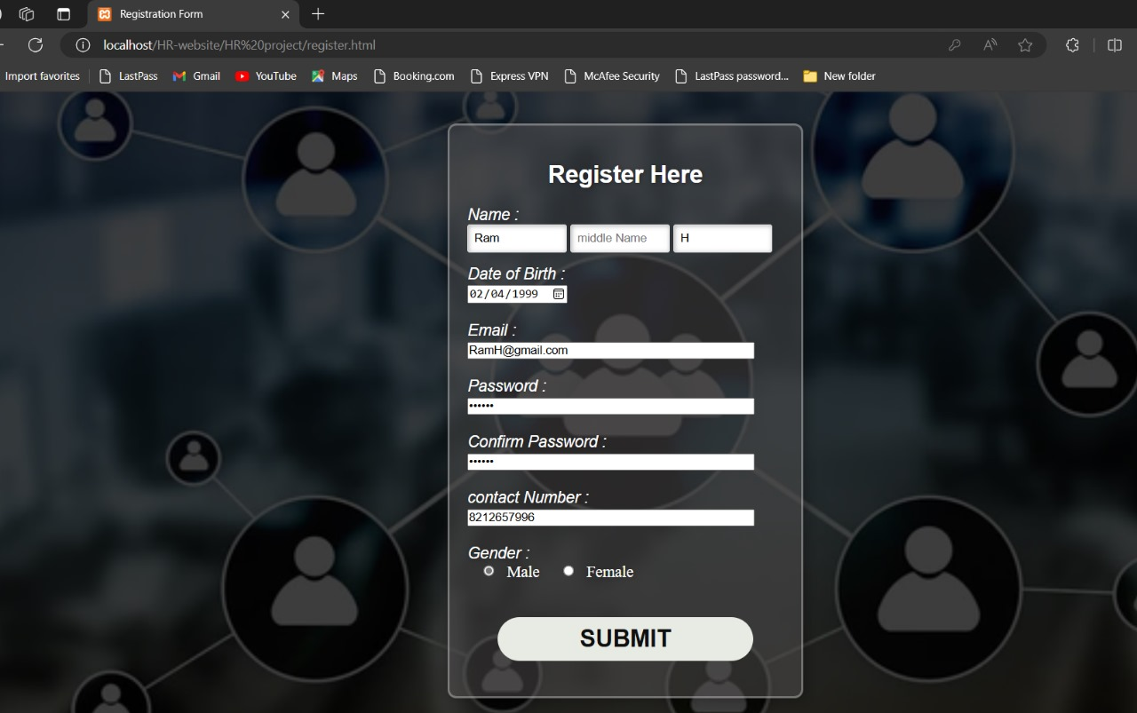

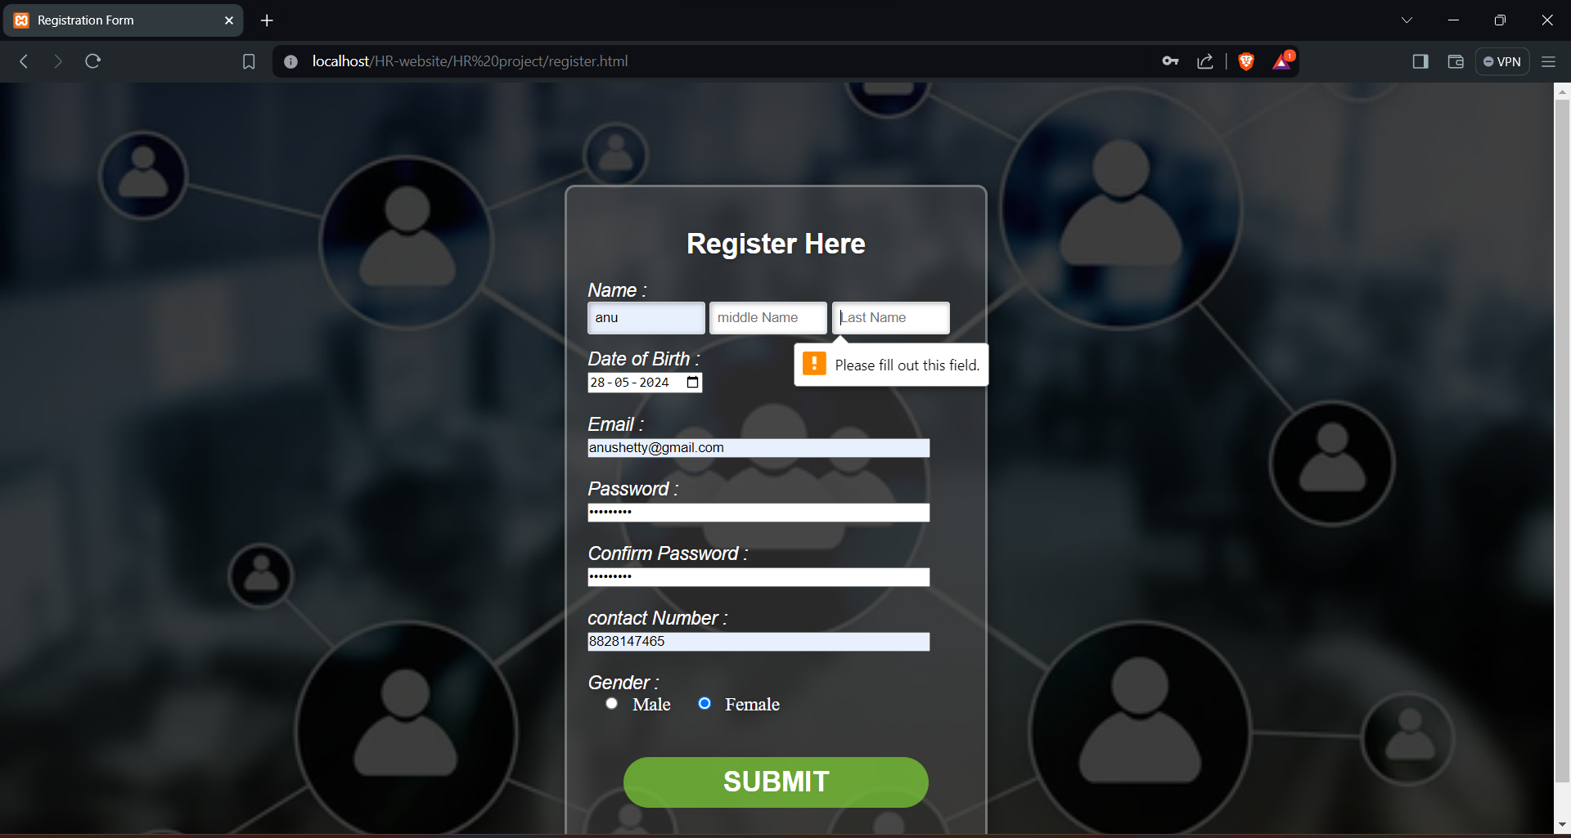

9.2 LOGIN FORM
Login as admin

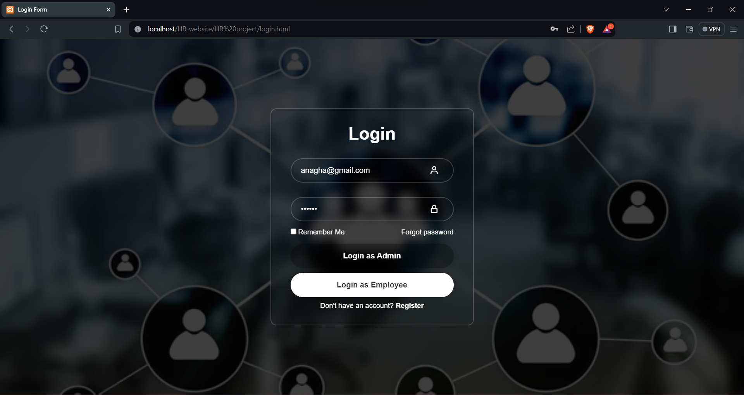

Login as employee

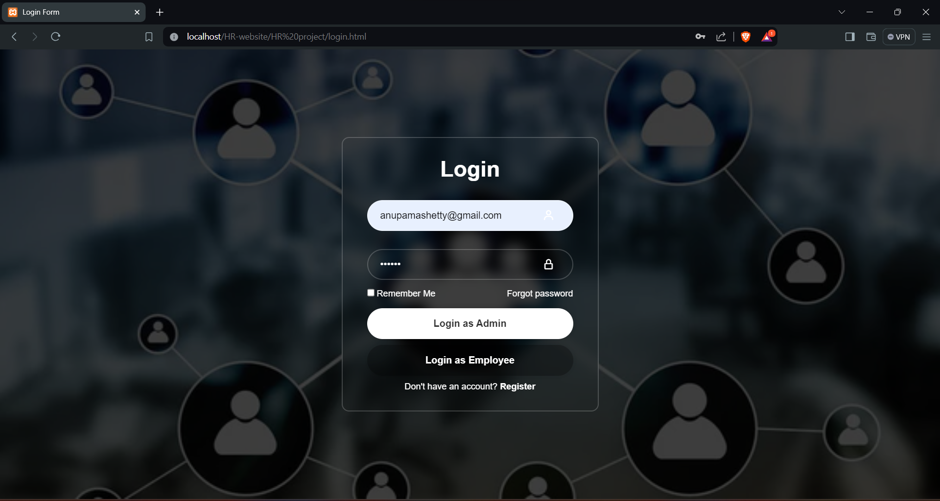

LIMITATION

CHP 10. LIMITATION

1. Complexity: HR systems can be tricky to learn and use because they're quite detailed and have lots of features.

2. Customization Troubles: It's hard to change things in HR systems to fit exactly what you need without spending a lot of time and money.

3. Connecting Problems: Sometimes, HR systems don't work well with other software, causing issues with sharing information between different parts of the company.

4. Security Worries: Since HR systems hold sensitive data about employees, they can be a target for hackers if they're not properly protected.

5. Scaling Challenges: As a company grows, the HR system might struggle to keep up with all the extra work and data, leading to slow performance.

6. Expensive: Getting and keeping an HR system running can be pricey, especially for smaller businesses.

7. Tech Reliance: If the HR system breaks or has issues, it can disrupt a lot of important tasks, causing headaches for everyone.

8. Getting Everyone Onboard: Sometimes, employees and managers don't want to use a new HR system, which can make it hard to get the full benefits.

9.Legal Rules: HR systems need to follow lots of rules about how they handle data and other things, which can be tough to keep up with.

10. Less Personal: With everything done online, there's less chance for personal interactions with HR staff, which can make some things feel less human.

CONCLUSION
CHP 11. CONCLUSION

The main feature of the "Human Capital Management System" is that all the information about the candidate, employees will be maintained electronically and now is provide to user at one place.

This information can be retrieved from database at anytime. In this way large amount of information can be stored and displayed electronically at a time, which reduces the paper cost required to maintain all these details.

With little more modifications and enhancement the project can be used by any other servicing company.

The project Human Capital Management System(HCMS) is for computerizing the work in the company. The software take care of all the requirements of an average company and is capable to provide easy and effective storage of information related to the candidates and employee who comes to the company. It generates matching, recruitment, selection, attendance and it also provides calculation of salary resume

The project is mainly built on the requirements which are used handle the candidates and employees who visit to the company.

An organization using this system should provide the employee with basic computer knowledge to use the system and they should be familiar with English and GUI knowledge.

BIBLIOGRAPHY

CHP 12. BIBLIOGRAPHY

Online References:

https://www.youtube.com/watch?v=nwj9Rf7qDDI

https://youtu.be/PgAZ8KzfhO8?si=Kj9ZpJ0OlwzyQXP6

Chat Gpt.

